

**Cleveland**

**Model Installation and Application**

**Guide**

Prepared by:

WSP | Parsons Brinckerhoff

November 9, 2015



# Table of Contents

Table of Contents i

List of Tables ii

List of Figures ii

1 Introduction 1

1.1 Model Overview 1

1.2 Directory Structure and File Naming 1

1.3 Input Files 4

2 Getting Started 5

2.1 Loading the Application on your Computer 5

Step 1: Copy All Model Files 5

Step 2: Update and Move NCSAM.ini 5

Step 3: Move TPBLOGO.BMP and TRUCK41.BMP 5

Step 4: MODEL_TABLE.BIN file 5

Step 5: SCEN_FILE.ARR file 5

Step 6: Install Add-In 6

Step 7: Open the GUI 6

3 Running Existing Scenarios 7

4 Model Report File 7

5 Scenario Planning 8

5.1 Scenario Inputs 8

5.2 Adding a New Scenario 8

5.3 Running a New Scenario 9

Appendix A A-1

# List of Tables

Table 1 File Names and Descriptions in Parameters Directory 2

Table 2 Scenario Input Files 3

Table 3 Scenario Interim Files 3

Table 4 Scenario Output Files 4

# List of Figures

Figure 1 Travel Model System Diagram 1

Figure 2 Directory Structure Diagram 2

# 1 Introduction

## Model Overview

Figure 1 shows a schematic of the Cleveland Urban Area Travel Demand Model. The model structure is patterned after the standard small area model adopted by the North Carolina Department of Transportation. The model is developed and applied completely within a Graphical User Interface (GUI).

Zonal Demographics & Land Use Data

Highway Networks

Trip Generation

Trip Distribution

Mode Choice

Trip Assignment

Level-of-Service Matrices (skims)

Commercial Vehicles and External Station Analysis

Time of Day

Figure 1 Travel Model System Diagram

## Directory Structure and File Naming

Proper application of the GUI requires that a specific directory structure and set of file-naming conventions be used. This directory structure uniquely identifies the location of files for each analysis year and scenario. The required directory structure is shown in Figure 2 and the required parameter files are shown in Table 1 and required input files are shown in Table 2. The TransCAD scenario manager is used to create scenarios and will by default look for these files by the names shown in the respective tables and in the relative directory structure shown in Figure 2. An optional directory for support files has also been included. The scenario manager allows extensive flexibility for changing the file names and locations, after a scenario is created with the default names.

Figure 2 Directory Structure Diagram

The required parameter files are included in the parameters directory and are applied to all scenarios. These files are described in Table 1.

Table 1 File Names and Descriptions in Parameters Directory

|  |  |
| --- | --- |
| File Name | Description |
| CAPACITYTABLE.BIN | BIN file with capacities |
| ALPHA.BIN | BIN file with standard values for alpha coefficient |
| HHSIZE.BIN | Default household size curve coefficients |
| AUTOS.BIN | Default auto ownership curve coefficients |
| JOINTDIST.BIN | Joint household size/auto ownership seed matrix |
| PRODRATES.BIN | Default trip production rates |
| ATTRRATES.BIN | Default trip attraction rates |
| CVPRODRATES.BIN | Default commercial vehicle trip production rates |
| CVATTRRATES.BIN | Default commercial vehicle trip attraction rates |
| IXATTRRATES.BIN | Default IX trip attraction rates |
| GAMMACOEFFICIENTS_LARGE*.BIN | Default Gamma Coefficients |
| KFACTORS.MTX | User defined matrix of K-factors (if needed) |
| MODESHARES_LARGE.BIN | Auto mode shares |
| VEHOCCUPANCYFACTORS_LARGE.BIN | Vehicle occupancy factors |
| HOURLY_LARGE.BIN | PA to OD TOD conversions |
| PEAKFACTORS_LARGE.BIN | Peak hour factors used to convert hourly capacity to time period capacity |

User required inputs are shown in Table 2. These inputs are scenario specific and should be placed in the input directory for the given scenario.

Table 2 Scenario Input Files

|  |  |
| --- | --- |
| File Name | Description |
| *_SEDATA.BIN | Zonal data inputs and external station inputs |
| BY_HIGHWAY.DBD | Base year highway line layer |
| *_HIGHWAY.DBD | Any future scenario line layer |
| *EE_TRIPS.MTX | Input through trip table for given year and/or scenario |

* Name or year of the scenario

An “Interim” folder is used to store interim files that are created during the model application process. These files are needed for reporting performance measures and running interim steps, but are not necessarily defined as final output.

Table 3 Scenario Interim Files

|  |  |
| --- | --- |
| File Name | Description |
| HBWGC_PATH.MTX | Generalized cost skims by trip purpose |
| HBOGC_PATH.MTX |
| NHBGC_PATH.MTX |
| BALANCE_PA.BIN | Initial balanced productions and attractions for internal trip purposes prior to adding non-resident trips |
| PER_TRIPS.MTX | Person trip table |
| AUTOPER_TRIPS.MTX | Auto person trip table |
| CV_TRIPS.MTX | Commercial vehicle trip table |
| IX_TRIPS.MTX | IX trip table |
| AMVEH_TRIPS.MTX | Auto vehicle trip tables by time of day |
| MDVEH_TRIPS.MTX |
| PMVEH_TRIPS.MTX |
| OPVEH_TRIPS.MTX |
| OP2VEH_TRIPS.MTX | Interim OP trip table for processing |
| AMCV_TRIPS.MTX | Commercial vehicle trip tables by time of day |
| MDCV_TRIPS.MTX |
| PMCV_TRIPS.MTX |
| OPCV_TRIPS.MTX |
| OP2CV_TRIPS.MTX | Interim OP CV trip table for processing |
| AMEE_TRIPS.MTX | Through trip tables by time of day |
| MDEE_TRIPS.MTX |
| PMEE_TRIPS.MTX |
| OPEE_TRIPS.MTX |
| OP2EE_TRIPS.MTX | Interim OP EE trip table for processing |
| AMIX_TRIPS.MTX | IX trip tables by time of day |
| MDIX_TRIPS.MTX |
| PMIX_TRIPS.MTX |
| OPIX_TRIPS.MTX |
| OP2IX_TRIPS.MTX | Interim OP IX trip table for processing |
| *_TLD_**.MTX | Trip length distribution files by purpose and impedance |

* Trip purpose ** Impedance value (generalized cost, travel time, or distance)

Final output files for each scenario are maintained in the “output” folder for a given scenario.

Table 4 Scenario Output Files

|  |  |
| --- | --- |
| File Name | Description |
| NETWORK.NET | Network file for path building and assignment |
| SHORTESTPATH.MTX | Skim matrix with zone to zone minimum travel time and associated distances. |
| GENCOST.MTX | Combined generalized cost matrix used in person trip distribution |
| BALANCE_PA2.BIN | Balanced productions and attractions for internal person trips (NHB*_NR trips included), CV trips, and IX trips. |
| BALANCE_CV.BIN |
| BALANCE_IX.BIN |
| AMTOT_TRIPS.MTX | Total vehicle trip tables by time of day |
| MDTOT_TRIPS.MTX |
| PMTOT_TRIPS.MTX |
| OPTOT_TRIPS.MTX |
| AM_LINKFLOW.BIN | Total vehicle link flow by time of day |
| MD_LINKFLOW.BIN |
| PM_LINKFLOW.BIN |
| OP_LINKFLOW.BIN |
| TOTAL_LINKFLOW.BIN | Daily total link flow |

## Input Files

#### *_SEDATA.BIN

This file contains all the internal and external zone fields and input data required by the model.

#### *_HIGHWAY.BIN

This file contains all the highway line layer fields and input data required by the model.

#### *_HIGHWAY_.BIN (corresponding node layer)

This *_HIGHWAY_.BIN file has a corresponding node layer.

#### *_EE_TRIPS.MTX

This is the through trip matrix for a given scenario.

# 2 Getting Started

## Loading the Application on your Computer

### Step 1: Copy All Model Files

To load the Model and prepare for execution, copy all the files from the DVD under the directory ClevelandTDM to the desired location on the hard drive. Be sure to check the file properties and set all files to allow read and write access.

### Step 2: Update and Move NCSAM.ini

Under the study area directory open Cleveland_config.ini with a text editor and modify the drive references to reflect the location of the model files on your computer. An example of this is shown below:

[Model Table]

c:\models\ClevelandTDM\Model UI\model_table.bin

[UI File]

c:\models\ClevelandTDM\Model UI\model_ui.dbd

[Scenario File]

c:\models\ClevelandTDM\Model UI\scen_file.arr

[Data Directory]

c:\models\ClevelandTDM\base year

After the file has been updated and saved, move it to the TransCAD program directory, located under ‘Program Files’. This is usually located under the C drive where the ‘tcw.exe’ is installed.

### Step 3: Move TPBLOGO.BMP and TRUCK41.BMP

Move the file Cleveland.BMP and TRUCK41.BMP in the bmp directory to the [TransCAD\bmp] directory. This will provide the necessary graphics for the GUI Main Menu.

### Step 4: MODEL_TABLE.BIN file

All information about default file names, directory names and parameters is stored in the model_table.BIN file. When a new scenario is created, TransCAD will look for the BIN file and populate the new scenario with the default information. This file can be viewed from and edited within TransCAD as any binary file. If any changes are made to the default file names or to the model application structure, then the BIN file will need to be updated.

User specified parameters are also included in this file, including the number of internal zones, the area type code, and the average wage rate.

### Step 5: SCEN_FILE.ARR file

When a scenario is created specific information about that scenario is stored in the ARR file. This file contains specific information about all scenarios that have been created through the model GUI. This file is not editable except through the user interface.

**NOTE: *Any scenarios previously created and executed cannot be recreated with the same results if the ARR file is deleted and the BIN file is changed. If scenarios need to be archived the entire set of directories with the BIN and the ARR files MUST be archived with the scenario data.***

### Step 6: Install Add-In

1. Tools – Setup Add-Ins
2. Add – Fill out the window as shown below

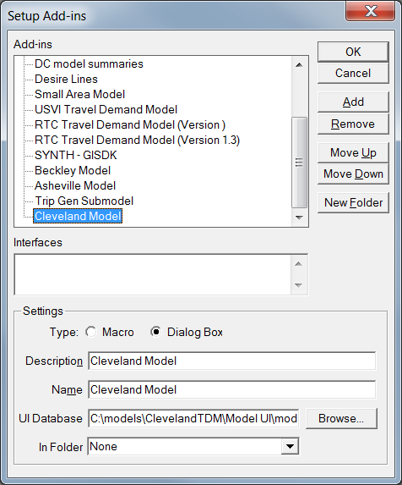

Browse to the directory where you stored the compiled program

This MUST be “Cleveland Model” exactly

Dialog Box

First select this button to add a new Add-in

You can give the Add-in any name

1. OK - This adds the program to the Add-In list (See Tools – Add-Ins)

### Step 7: Open the GUI

1. Tools – Add-Ins – Cleveland Model
2. The model GUI will be displayed and you are now ready to set up scenarios and run the model.

# 3 Running Existing Scenarios

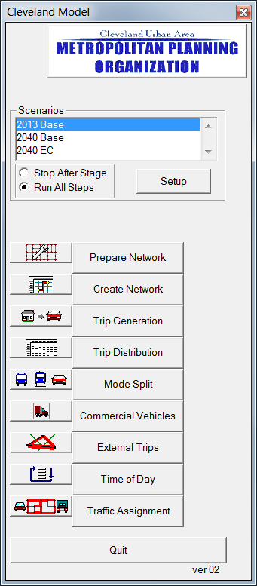

These buttons are selected for running each step. If the box to run all steps is selected, clicking on prepare network will run all steps of the model, otherwise only the step selected will run.

Check this box to run all steps [NOTE: if you want to run step by step check the other box instead.

Select the scenarios

You can view the files associated with each scenario by highlighting the scenario in question and selecting the “Setup” button. This opens the Project Scenarios window. From there you can highlight a specific step and view the input and output files by selecting the “Contents” button.

# 4 Model Report File

A model report file is generated for each scenario that is specified and run. The report file is a text file that includes model performance outputs from each model stage where model performance output is required. The output from each subsequent stage is simply appended to the end of the report file.

# 5 Scenario Planning

Scenarios are created and edited by selecting the “Setup” button from the user interface. All information about default file names, directory names, and parameters are stored in the MODEL_TABLE.BIN file as described earlier. When a new scenario is created, TransCAD will look for the MODEL_TABLE.BIN file and populate the new scenario with the default information. This file can be viewed from and edited within TransCAD as any binary file. Specific information about all scenarios that a user has created is stored in the SCEN_FILE.ARR file. This file is not editable except through the user interface.

## 5.1 Scenario Inputs

The required files for running a new scenario include model parameter files and model input files. The model parameter files, listed in Table 1, contain model constants, coefficients, rates, and other parameters that should not be changed for a given scneario. Only the input files listed in Table 2 can be updated without recalibrating the model set.

## 5.2 Adding a New Scenario

To add a new scenario click the “Setup” button on the user interface. The Project Scenarios window will be displayed. From this window scenarios can be added, deleted, and sorted. All available scenarios will be listed in the list box with the date and time of creation. A box is provided for a detailed description of the scenario.

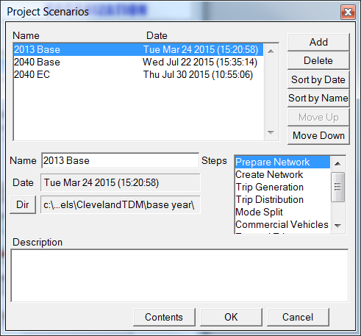

Select to choose directory

Each scenario must have its own directory, and the directory and required subdirectories (See Figure 2) must already exist. If the directories exist, the user can select the DIR button and, using the Windows-like browser, select the location of the scenario data files and subdirectories.

Each stage of the model application is listed in the “Parameters for Step…” list box as described previously. These are the same Stages listed on the model user interface. As demonstrated previously, selecting the Contents button will display the input and output data files, and any applicable parameter for the highlighted Stage.

The user can select to view either the input or the output files by selecting the appropriate radio button under the file listing scroll box. The status column indicates whether or not the file already exists. As with the base year scenario, the user should check to see that all input files exist before executing the model. Further, if performance testing and output files from previous runs need to be saved, the user can change the name and/or location of the output files in order to avoid overwriting existing files. The highlighted file can be changed with the File button. The Dir button allows for global changes to file locations. The Open button allows the user to open and view the TransCAD file that is highlighted in order to verify the contents.

## 5.3 Running a New Scenario

Once all input files for the new scenario are ready and the scenario has been set up the user can then run through all of the model stages to prepare new model outputs for the scenario. The user must review the reasonableness of the results and compare the base year and other scenarios to verify that the model has been run correctly and the results are in line with the underlying changes in land use and transportation networks.

# Appendix A

**Table A-1 SEDATA Required Inputs**

|  |  |  |  |  |  |
| --- | --- | --- | --- | --- | --- |
| Field Name | Field Type | Width | Decimal | Data Value* | Description |
| TAZ | Integer (4 bytes) | 10 | 0 | R | Traffic analysis zone |
| HHPopulation | Integer (4 bytes) | 11 | 0 | R | Population in zone |
| Households | Integer (4 bytes) | 11 | 0 | R | Households in zone |
| Vehicles | Integer (4 bytes) | 10 | 0 | R | Autos in zone |
| Industry | Integer (4 bytes) | 11 | 0 | R | Industry employees |
| Retail | Integer (4 bytes) | 11 | 0 | R | Retail employees |
| HwyRet | Integer (4 bytes) | 11 | 0 | R | Highway retail employees |
| Service | Integer (4 bytes) | 11 | 0 | R | Service employees |
| Office | Integer (4 bytes) | 11 | 0 | R | Office employees |
| TotEmp | Integer (4 bytes) | 11 | 0 | R | Total employment |
| Students | Integer (4 bytes) | 11 | 0 | R | Students |
| CV1IND | Integer (4 bytes) | 8 | 0 | R | Autos at industry site |
| CV2IND | Integer (4 bytes) | 8 | 0 | R | Pickups at industry site |
| CV3IND | Integer (4 bytes) | 8 | 0 | R | Trucks at industry site |
| CV1RET | Integer (4 bytes) | 8 | 0 | R | Autos at retail site |
| CV2RET | Integer (4 bytes) | 8 | 0 | R | Pickups at retail site |
| CV3RET | Integer (4 bytes) | 8 | 0 | R | Trucks at retail site |
| CV1HWY | Integer (4 bytes) | 8 | 0 | R | Autos at highway retail site |
| CV2HWY | Integer (4 bytes) | 8 | 0 | R | Pickups at highway retail site |
| CV3HWY | Integer (4 bytes) | 8 | 0 | R | Trucks at highway retail site |
| CV1SER | Integer (4 bytes) | 8 | 0 | R | Autos at service site |
| CV2SER | Integer (4 bytes) | 8 | 0 | R | Pickups at service site |
| CV3SER | Integer (4 bytes) | 8 | 0 | R | Trucks at service site |
| CV1OFF | Integer (4 bytes) | 8 | 0 | R | Autos at office site |
| CV2OFF | Integer (4 bytes) | 8 | 0 | R | Pickups at office site |
| CV3OFF | Integer (4 bytes) | 8 | 0 | R | Trucks at office site |
| ixp | Real (8 bytes) | 10 | 2 | R | IX productions |

**Table A-3 HIGHWAY Line Layer Required Inputs**

|  |  |  |  |  |  |
| --- | --- | --- | --- | --- | --- |
| Field Name | Field Type | Width | Decimal | Data Value* | Description |
| ID | Integer (4 bytes) | 10 | 0 | R | Link ID |
| Length | Real (8 bytes) | 10 | 2 | R | Link length |
| Dir | Integer (2 bytes) | 2 | 0 | R | Link DIR |
| Posted Speed | Real (8 bytes) | 10 | 2 | R | Link posted speed |
| FACTYPE_CD | Integer (4 bytes) | 10 | 0 | R | Link facility type code |
| DIVIDED_CD | Integer (4 bytes) | 6 | 0 | R | Cross-section code |
| AB Lanes | Integer (4 bytes) | 6 | 0 | R | Number of lanes AB |
| BA Lanes | Integer (4 bytes) | 6 | 0 | R | Number of lanes BA |
| FUNCL_CDtorem | Integer (2 bytes) | 6 | 0 | R | Functional class code |
| AB Count | Integer (4 bytes) | 10 | 0 | R | Link count AB and BA |
| BA Count | Integer (4 bytes) | 10 | 0 | R |
| DailyCount | Integer (4 bytes) | 10 | 0 | R | Link daily count |
| Screenline | Integer (4 bytes) | 10 | 0 | R | Screenline link indicator |